**Shopping Cart Problem - Easy**

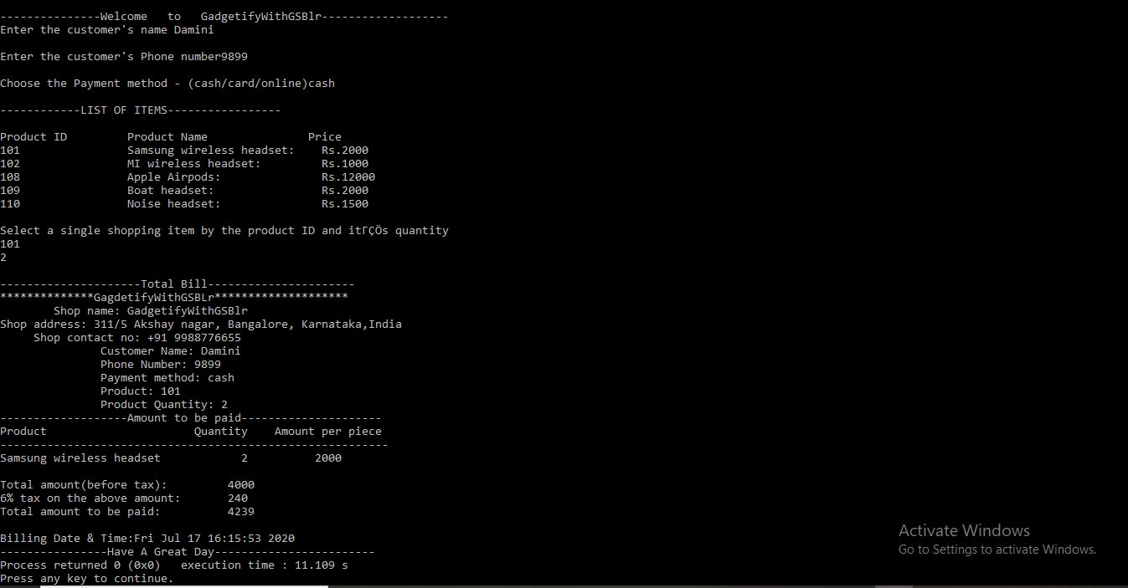

I have solved this problem using C++.I have used strings, functions, arrays, associative arrays and basic numerical operations to calculate the bill.

I have used getline to take input as it is convenient for accepting a string with multiple spaces and have done the required formatting to make it look presentable. I have done all the calculations related to the bill in the function calculate which takes 2 parameters(product name and quantity)